APP introduce

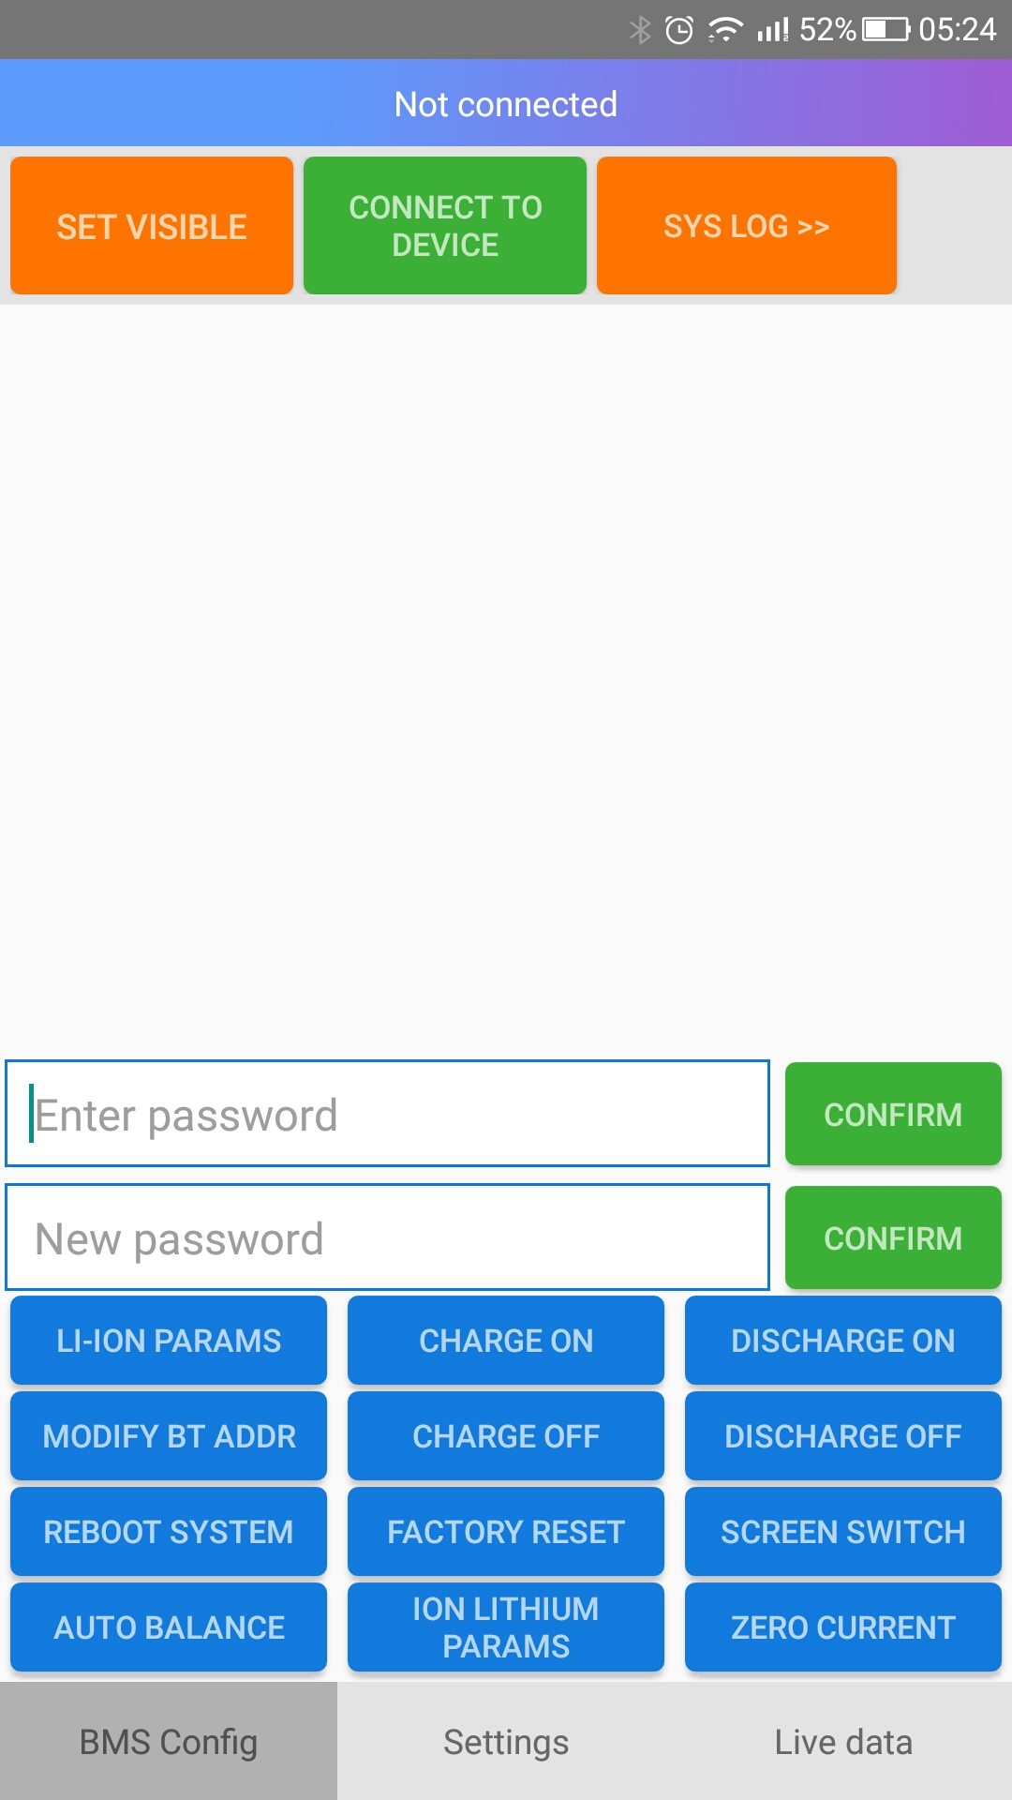

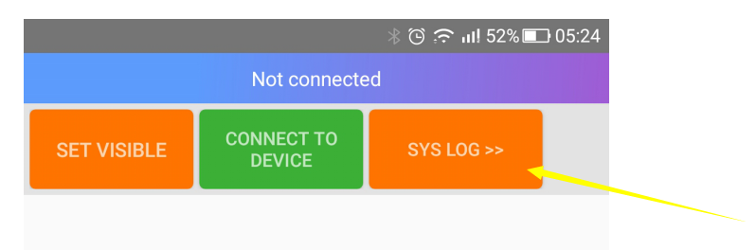
“SYS LOG” ---- View historical protection records

Default the board no password, you can set the password, so other people can not change the parameter. Input 8 number as new password, next time, if you want to change any parameter, you need input the password. (Bluetooth pairing password is still 1234, not affected by this password)
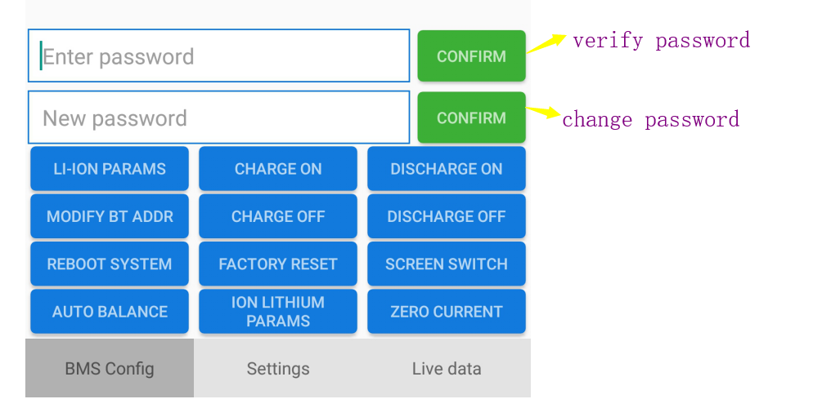
(There is a little translation error)
Default is Li-ion(3.7V) parameter, if your battery is LiFePO4 or LTO, you can press the menu change the battery type.

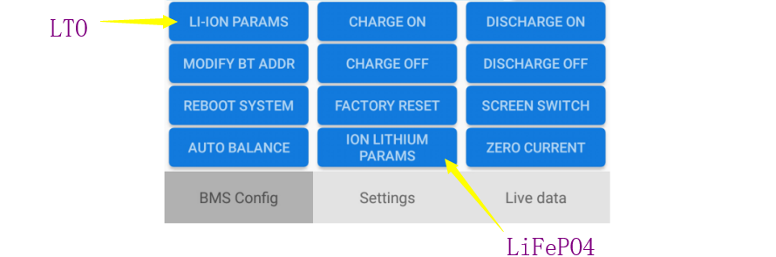
If you have a lot of ANT board, you can change the address of Bluetooth by “ MODIFY BT ADDR”.
This makes it easy to distinguish which piece of BMS is connected.

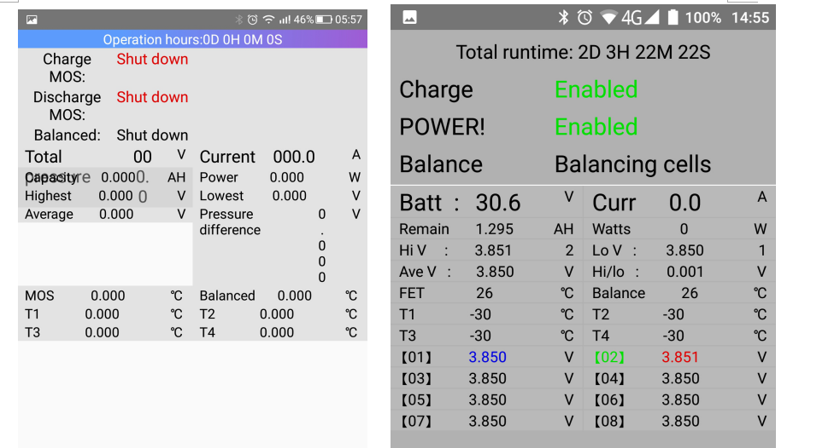

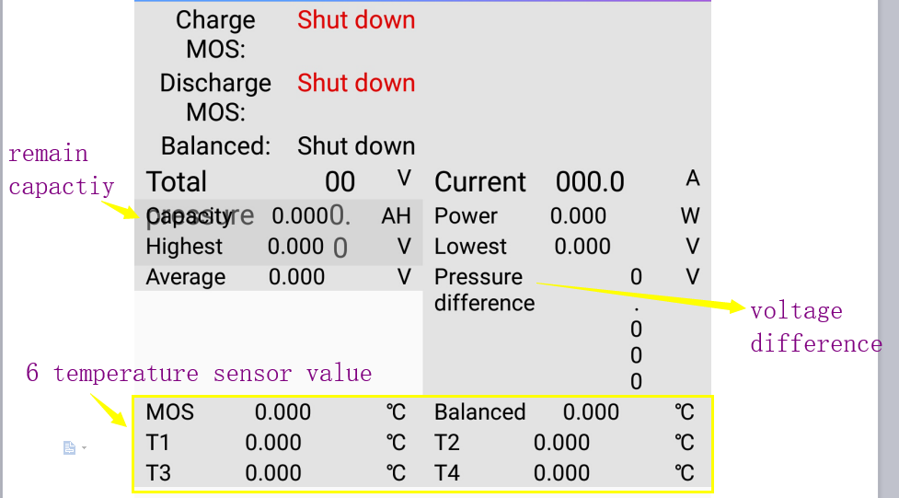

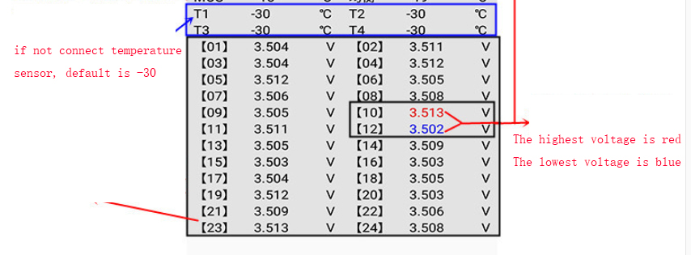
Default the parameter is for Li-ion(3.7V). if your battery is LTO or LiFePO4, you need set it in the first page.
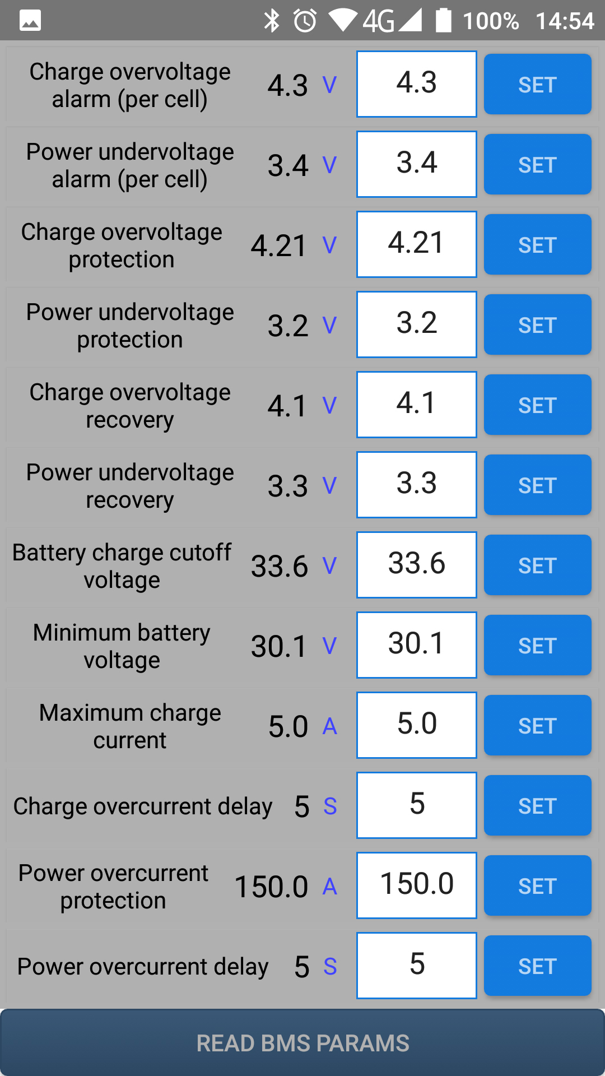

Any item. If you can not understand, you can long press the item, will pop up an explanation

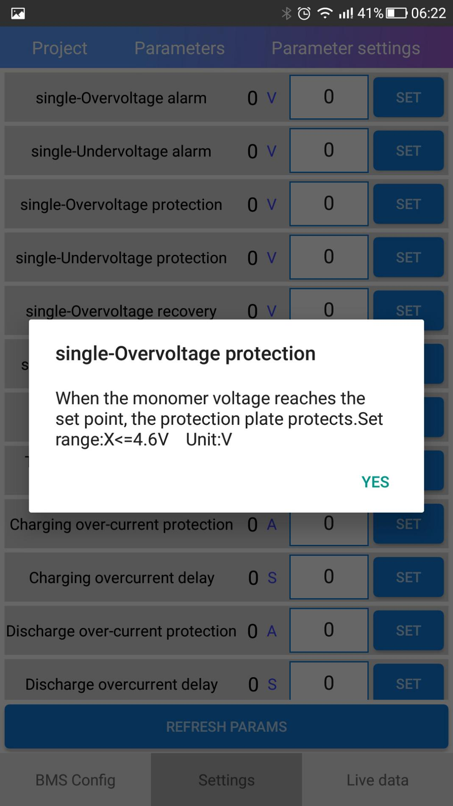
“System reference voltage” -------if detect cell voltage is not correct, you can use this parameter to calibrate.
“Current sensing range”------if detect current is not correct, you can use this parameter to calibrate.
“Actual number of batteries”----- set it base your batter pack, eg: if battery is 20S, then you set to 20S.
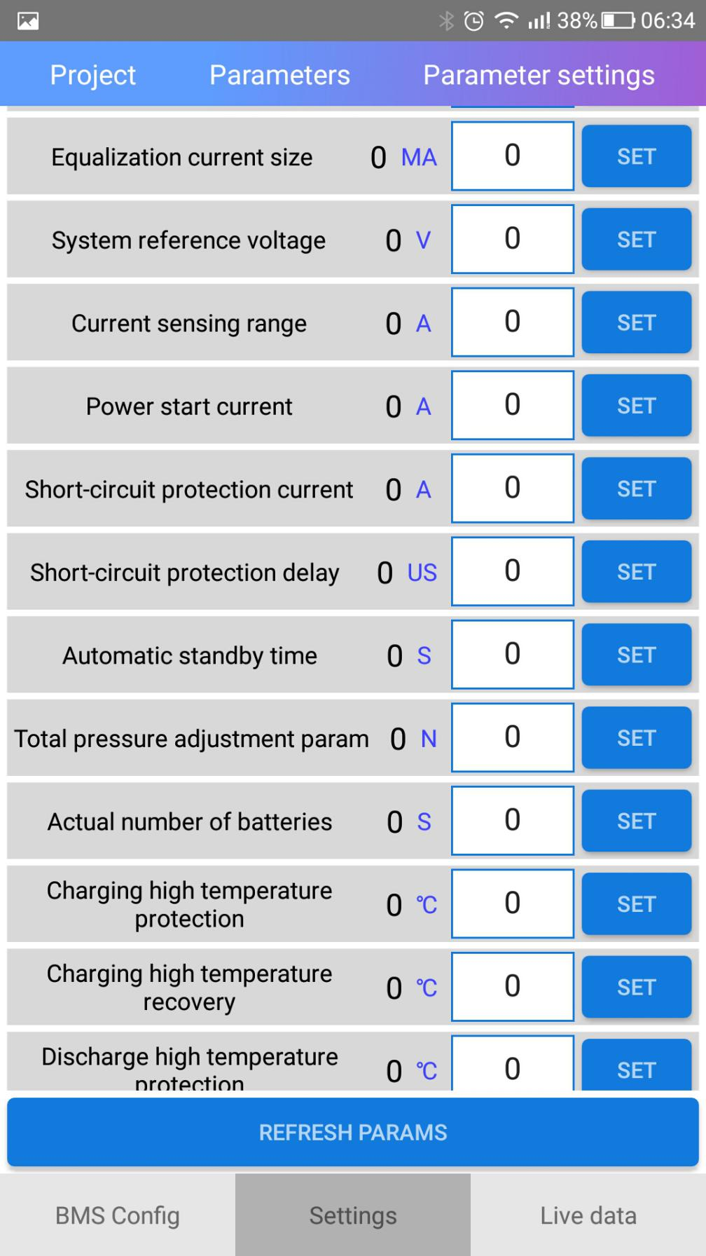
“Battery physical capacity”-----please set the capacity of your battery pack.

